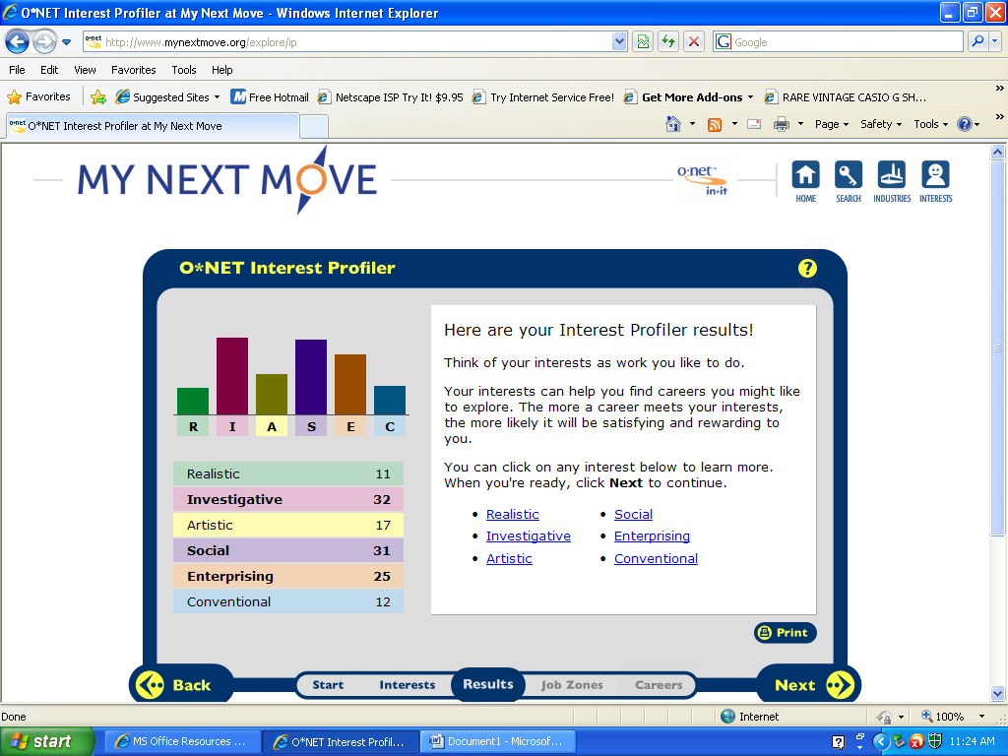
My career explorations said that I am most investigative. I agree somewhat that I am because I would like to be a pharmacist and would not mind being in that field. They say that investigative people like to research and go after challenges. I am one of those people that if I had learned something I love to research and learn more detail. Growing up, my family I always taught me to challenge myself and never take the easy way out. However, I believe I am more social because I would love to be in the nursing field. I rather be hands on with the patients than being behind a desk or in a lab. I am a sociable person and work well with others. I am one for working in groups and constantly going out to places. I do not like to be stuck indoors. I enjoy joining clubs and attending sports events as well.

Social Services
Marriage and Family Therapist- ask questions to the clients to help identify their behavior; help develop new skills for the families and couples to work together. A social worker is a related occupational field. The personality trait that best fits this field is social. A master's degree in marriage and family counseling is a two to three year program along with a license. They are also required to complete an internship, which is supervised by a professional and usually takes up more than half of their final year of study. Some technology skills they need to know how to use Microsoft offices, spreadsheets, accounting software’s, and internet browser software. They have an expected growth rate of 18% over the next ten years. You can find jobs anywhere, such as the Phoenix House in Dorchester. Therapy usually consists of talk sessions, lasting about an hour. It is a lot of sitting and finding ways to help the couples or families. Marriage and family therapist are not part of the union. A doctoral degree can open up many doors for marriage and family therapists, such as research, teaching, or a professorship in a university. Ten percent of the therapists make an annual $23,870; twenty-five percent makes $34,420, and fifty percent make $45,720, and ninety percent make $72,280.

Social Worker-assist people in managing their daily lives, navigating relationships, and coping with issues. A counselor or a family therapist is a related occupational field. The personality trait that best fits this field is social. Social workers must go to a four year college, and before they can get a job, social workers need a license, certification, or registration. They must know how to social, organizational, and technological systems work and operates effectively within them. The middle 50 percent earned between $31,040 and $52,080. The lowest 10 percent earned less than $25,870, and the top 10 percent earned more than $66,430. Between 2008 and 2018, jobs for social workers are expected to grow faster than the average for all occupations. Social workers are not part of a union. Most social workers spend the day in an office or travel to the people that need help. Sometimes, they meet with people in the evening or on weekends. Many social workers have their own businesses. Advancement to supervisor, program manager, assistant director, or executive director of a social service agency or department usually requires an advanced degree and related work experience.

Nursing, Therapy, & Health Promotion
Occupational Therapist - health professional that specializes in evaluation and treatment of different diagnoses that limit functional independence. A physical therapist is another occupational field. You must have a good social personality in order to be in this field. A master's degree or higher in occupational therapy is the requirement to be in the field. Occupational therapists must attend an academic program accredited by the Accreditation Council for Occupational Therapy Education in order to sit for the national certifying exam. The middle 50 percent earned between $55,090 and $81,290. The lowest 10 percent earned less than $42,820, and the highest 10 percent earned more than $98,310. The work atmospheres are in large rehabilitation centers where therapists work in spacious rooms with machines, tools, and other devices generating noise. The work can be tiring because therapists are on their feet most of the time. Occupational therapists are expected to increase by 26 percent between 2008 and 2018, which is faster than the average for all occupations. They are not part of a union. They may advance their careers by taking on administrative duties at hospitals or rehabilitation centers. Some technological are accounting software, billing software, spreadsheet software, and medical software.

Physical Therapist- use variety of treatments to help build strength, improve movement, and strengthen skills needed to complete a task. A physician assistant is a related occupational field. The best personality trait for this field is social. Master's degree programs typically are 2 to 2.5 years in length, while doctoral degree programs last 3 years. A number of States require continuing education as a condition of maintaining their license. Physical therapists are expected to grow by 30 percent from 2008 to 2018. The middle 50 percent earned between $60,300 and $85,540. The lowest 10 percent earned less than $50,350, and the highest 10 percent earned more than $104,350.Physical therapists practice in hospitals, outpatient clinics, and private offices that have equipped facilities. These jobs use physical labor because therapists may have to kneel, crouch, lift, and stand for long periods of time. They are not part of a union. Physical therapists can advance by continuing education courses and workshops. Some physical therapists become board certified in a clinical specialty. Some technology skills needed are calendar and scheduling software, medical software, Microsoft Excel, and word processing software.

Physician Assistant - they take medical histories, examine and treat patients, order and interpret laboratory tests and x rays, and make diagnoses. They can also prescribe medication to patients. A registered nurse is a related occupational field. You must have a good social personality in order to be in this field. Their work environment consists of walking around all day and the workweek of hospital-based physician assistants may include weekends, nights, or early morning hospital rounds to visit patients. Physician assistant educational programs usually take at least two years to complete for full-time students. The programs include supervised clinical training, including family medicine, internal medicine, surgery, prenatal care, and pediatrics. Some pursue additional education in a specialty. They can advance in programs that are available in areas such as internal medicine, rural primary care, emergency medicine, surgery, pediatrics, neonatology, and occupational medicine. The middle 50 percent of physician assistants earned between $68,210 and $97,070. The lowest 10 percent earned less than $51,360, and the highest 10 percent earned more than $110,240. They are not part of a union and their outlook is expected to grow by 39 percent from 2008 to 2018. Some technology skills that physician assistants need to have are internet browser software, medical software, spreadsheet software, video conferencing software, and word processing software. In management, nurses can advance from assistant unit manager or head nurse to administrative roles of assistant director, director, vice president, or chief of nursing.

Registered Nurse - treats patients, educate patients and the public about various medical conditions, and provide advice and emotional support to patients' family members. RNs record patients' medical histories and symptoms help perform diagnostic tests and analyze results. An occupational therapist is a related occupational field. In order to be in this field, you must have a good social personality. Patients in hospitals and nursing care facilities require 24-hour care and nurses may have to work nights, weekends, and holidays. This job requires a lot of standing, walking, bending, and stretching. In all States, the District of Columbia, and U.S. territories, students must graduate from an approved nursing program and pass a national licensing examination. They need a bachelor's of science degree in nursing, an associate degree in nursing, and a diploma. The middle 50 percent earned between $51,640 and $76,570. The lowest 10 percent earned less than $43,410, and the highest 10 percent earned more than $92,240.They are part of a union and there outlook in the future is expected to grow by 22 percent from 2008 to 2018, much faster than the average for all occupations. The growth will be driven by technological advances in patient care. Some technology skills they need to have are medical software, office suite software, spreadsheet software, and time accounting software. Hospitals employed the majority of RNs, with 60 percent of such jobs. Others work in government agencies, social assistance agencies, and educational services.

Child & Adult Care
Medical Assistant- performs administrative and clinical tasks to keep the offices of physicians, podiatrists, chiropractors, and other health practitioners running smoothly. A nurse’s aide is a related occupational field. In order to be in this field, you must have a good social personality. Most full-time medical assistants work a regular 40-hour week in clean environments. Medical assisting programs are offered in vocational-technical high schools, postsecondary vocational schools, and community and junior colleges. Postsecondary programs usually last either one year and result in a certificate or diploma, or two years and result in an associate degree. Some can advance by teaching medical assistance, and others pursue education to become nurses or other healthcare workers. You can find these jobs in hospitals, doctor’s offices, outpatient care centers and nursing and residential care facilities. Employment of medical assistants is expected to grow 34 percent from 2008 to 2018. The middle 50 percent earned between $23,700 and $33,050. The lowest 10 percent earned less than $20,600, and the highest 10 percent earned more than $39,570. They are not part of a union and some technology skills needed are accounting software, electronic mail software, medical software, office suite software, and operating system software.
Health Sciences
Pharmacist- helps patients and the community by providing information and advice on health, and providing medications. A pediatrician is a related occupational field. To be in this field, you must have an investigative personality. Pharmacists work in clean environments. Many pharmacists spend most of their workday on their feet and they work with sterile or dangerous pharmaceutical products. Pharmacists who are trained in the United States must earn a Pharm.D degree from an accredited college or school of pharmacy. Most applicants have completed 3 or more years at a college or university before moving on to a Pharm.D program. Pharmacists are not part of a union. You can find jobs at Walgreens, Stop and Shop, hospitals, or even CVS. There is a large role of medications and their use play throughout these issues, pharmacists will have an important role in the future of healthcare. Growth will increase and there will be plenty of job openings in the future. Some technology skills that pharmacist’s needs are accounting software, data base user interface and query software, inventory management software, label making software, and medical software. Pharmacists with an interest in management may elect to advance into a Senior Pharmacist. The next level of advancement within the department would be at the Division Manager level.
Percentile | 10% | 25% | 50%  (Median) | 75% | 90%
Hourly Wage | $39.47 | $47.50 | $53.64 | $60.45 | $66.64
Annual Wage (2) | $82,090 | $98,810 | $111,570 | $125,740 | $138,620

Colleges Interested In
I always knew I wanted to go into the medical field, but by doing this assignment has definitely confirmed my answer. I have a social personality, which fits perfect into this field because you need to be able to communicate well with others. The salary intake is well and the college education I know I can do. There are some colleges I am interested in going to for the jobs that I am interested in and they are University of Rhode Island, UMASS Amherst, and UMASS Dartmouth. These colleges are known for their medical fields and these are the schools I wish to apply.

